Closed Wavy Shapes

Definition
# Source: AI Source: Provided by: [Data Path: Persons Table -> ID Column: 1, Name_En Column: Motasem Essam] -> From: [ChatGPT] on [7/25/2026]
A Closed Wavy Shape is a wavy shape whose boundary forms a continuous closed curve, with no endpoints, and encloses a region of the plane.
Its boundary usually consists of smooth, continuously changing curves rather than straight segments with sharp corners.
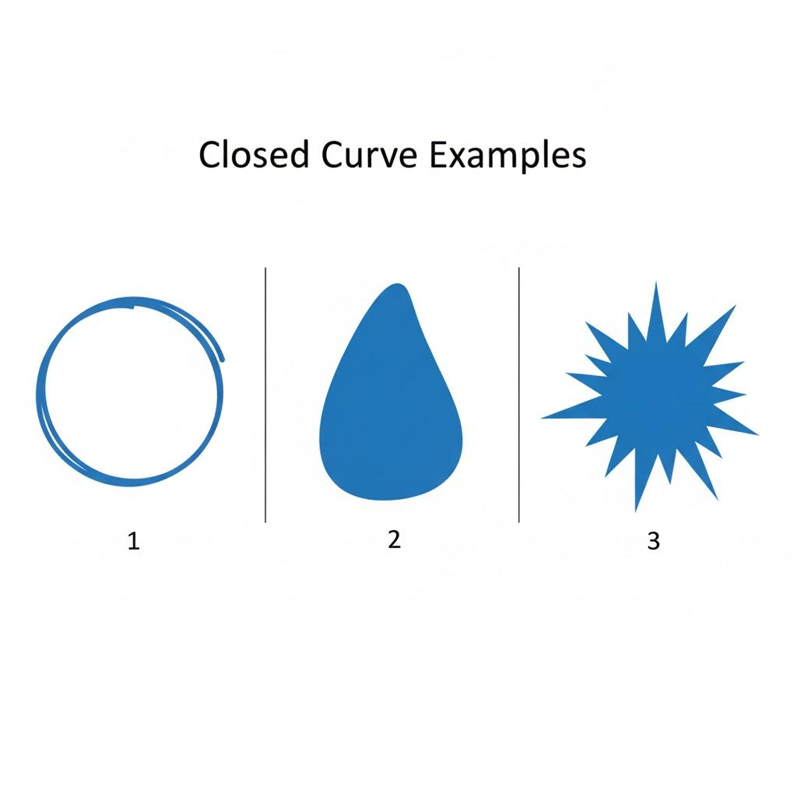
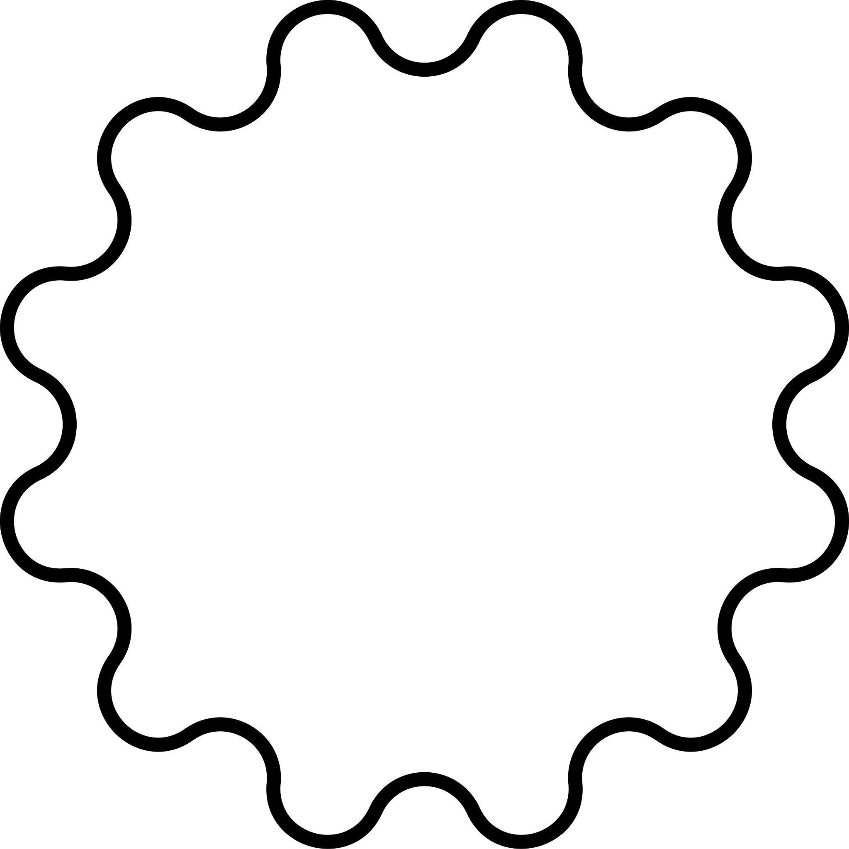
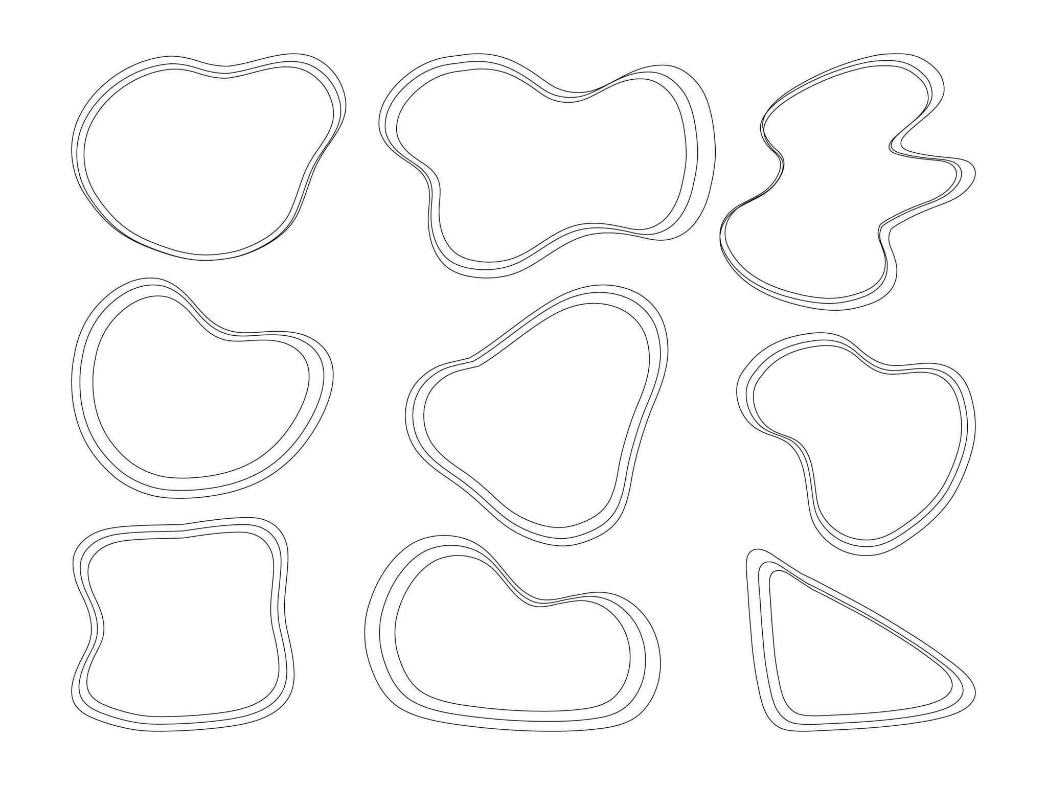
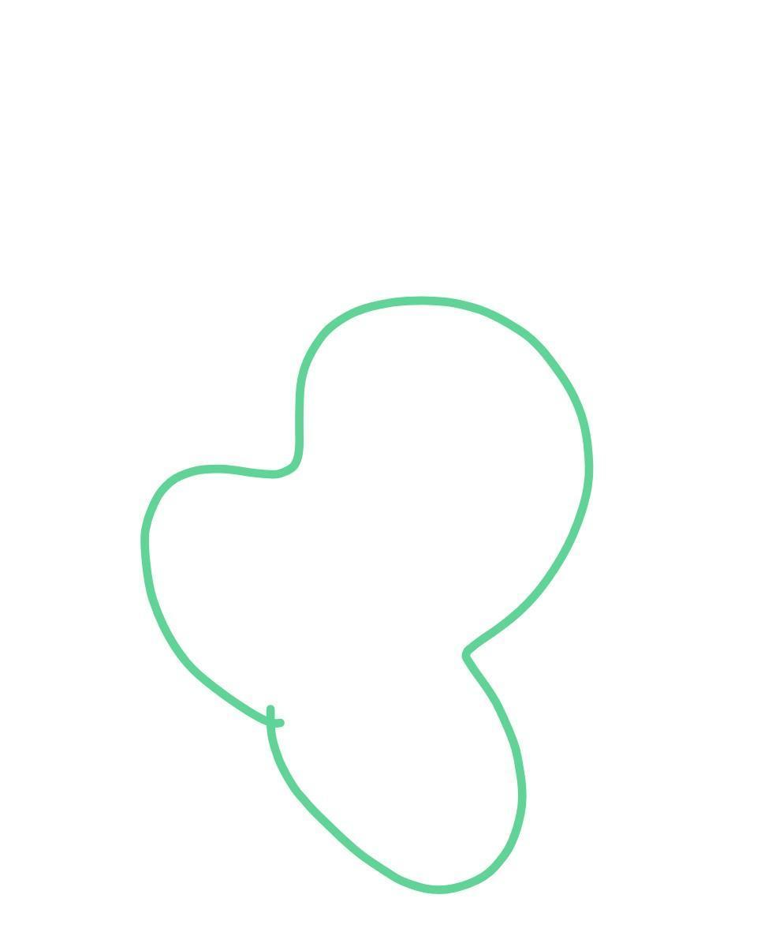
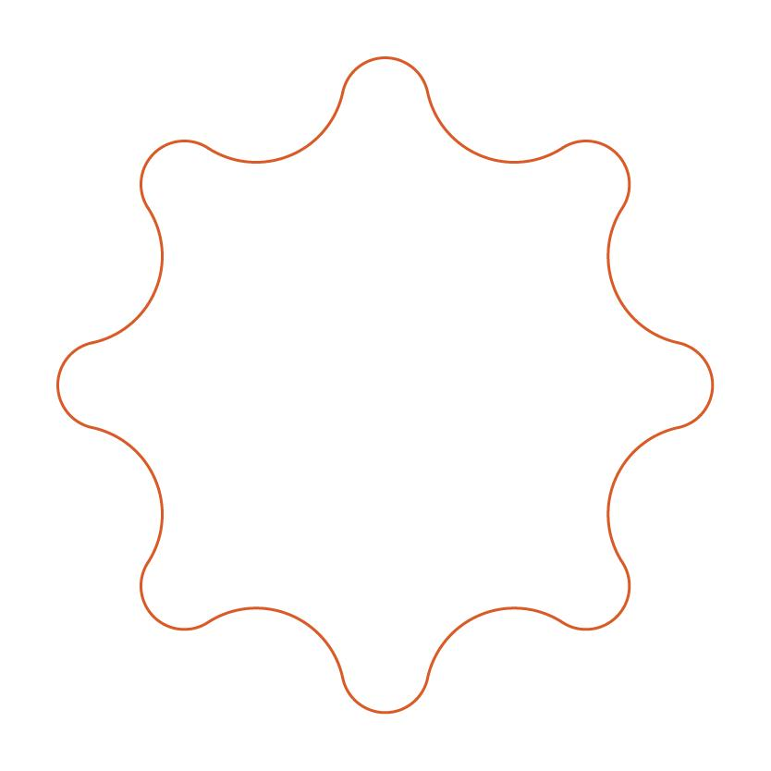

Fundamental Concept
# Source: AI Source: Provided by: [Data Path: Persons Table -> ID Column: 1, Name_En Column: Motasem Essam] -> From: [ChatGPT] on [7/25/2026]
The essential property of a closed wavy shape is that its boundary:
- Starts at a point.
- Continuously changes direction.
- Eventually returns to the starting point.
- Has no free endpoints.
- Encloses a region.
A closed wavy shape can be represented conceptually as:
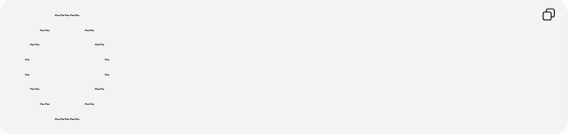
~~~~~
~~ ~~
~~ ~~
~ ~
~ ~
~~ ~~
~~ ~~
~~~~~
The exact boundary does not need to be circular, elliptical, or another standard geometric curve.

Main Characteristics
# Source: AI Source: Provided by: [Data Path: Persons Table -> ID Column: 1, Name_En Column: Motasem Essam] -> From: [ChatGPT] on [7/25/2026]
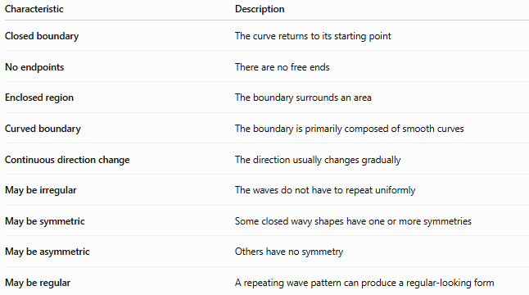
Characteristic | Description
Closed boundary | The curve returns to its starting point
No endpoints | There are no free ends
Enclosed region | The boundary surrounds an area
Curved boundary | The boundary is primarily composed of smooth curves
Continuous direction change | The direction usually changes gradually
May be irregular | The waves do not have to repeat uniformly
May be symmetric | Some closed wavy shapes have one or more symmetries
May be asymmetric | Others have no symmetry
May be regular | A repeating wave pattern can produce a regular-looking form

Basic Structure
# Source: AI Source: Provided by: [Data Path: Persons Table -> ID Column: 1, Name_En Column: Motasem Essam] -> From: [ChatGPT] on [7/25/2026]
A closed wavy shape can be considered as a closed curve:
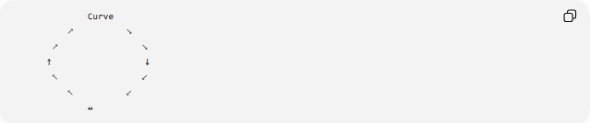
Curve
↗ ↘
↗ ↘
↑ ↓
↖ ↙
↖ ↙
↔
Mathematically, a closed curve can be parameterized by
$$r\left(t\right)=\left(x , \left(t\right)y\left(t\right)\right)$$
with a parameter interval
$$a≤t≤b$$
and the closure condition
$$r\left(a\right)=r\left(b\right)$$
This means that the curve ends at the same point where it began.

Types of Closed Wavy Shapes
# Source: AI Source: Provided by: [Data Path: Persons Table -> ID Column: 1, Name_En Column: Motasem Essam] -> From: [ChatGPT] on [7/25/2026]
Closed wavy shapes can be classified according to their pattern and symmetry.

1-Regular Closed Wavy Shapes
# Source: AI Source: Provided by: [Data Path: Persons Table -> ID Column: 1, Name_En Column: Motasem Essam] -> From: [ChatGPT] on [7/25/2026]
A Regular Closed Wavy Shape has a repeating or highly consistent wave pattern around its closed boundary.
Typical characteristics:
- Repeated wave pattern.
- Consistent amplitude or curvature.
- Repeated spacing.
- Often has symmetry.
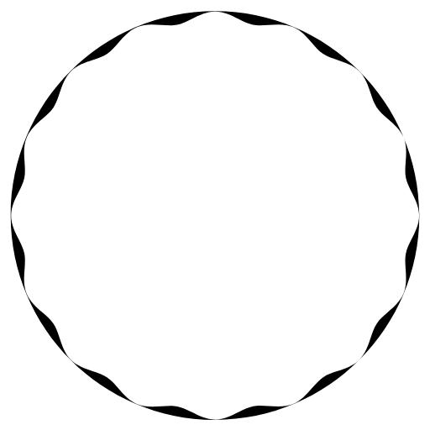
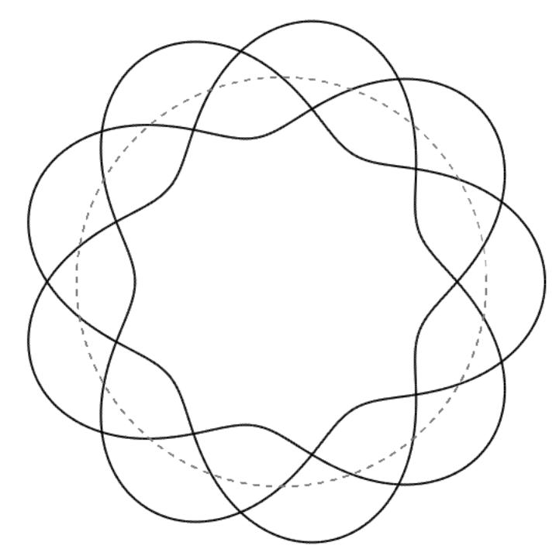
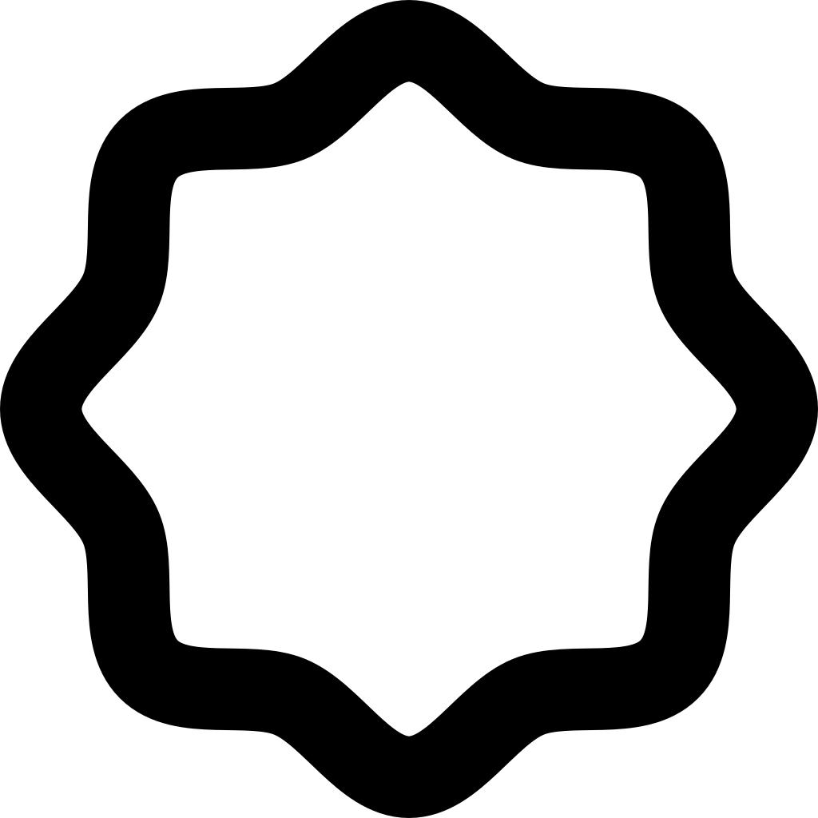
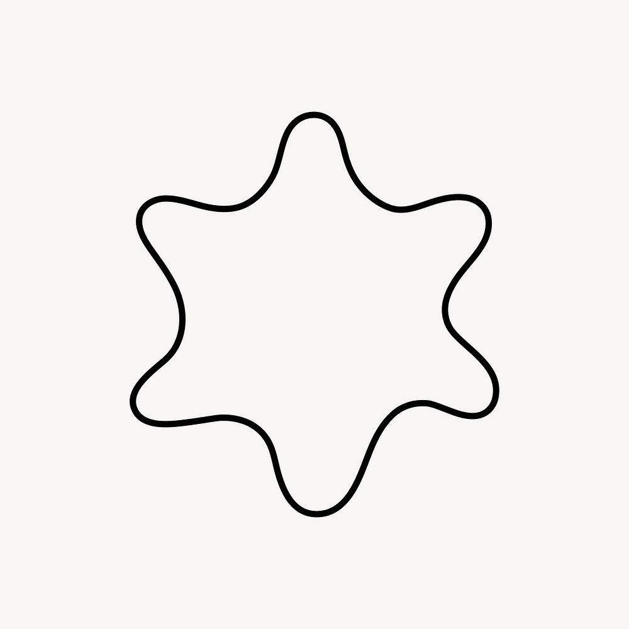

2-Irregular Closed Wavy Shapes
# Source: AI Source: Provided by: [Data Path: Persons Table -> ID Column: 1, Name_En Column: Motasem Essam] -> From: [ChatGPT] on [7/25/2026]
An Irregular Closed Wavy Shape has a closed boundary in which the waves vary in size, spacing, curvature, or amplitude.
For example:
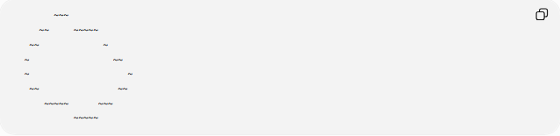
~~~
~~ ~~~~~
~~ ~
~ ~~
~ ~
~~ ~~
~~~~~ ~~~
~~~~~
Its wave pattern does not repeat uniformly.
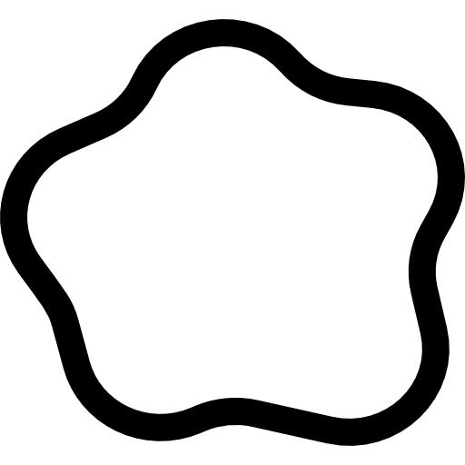
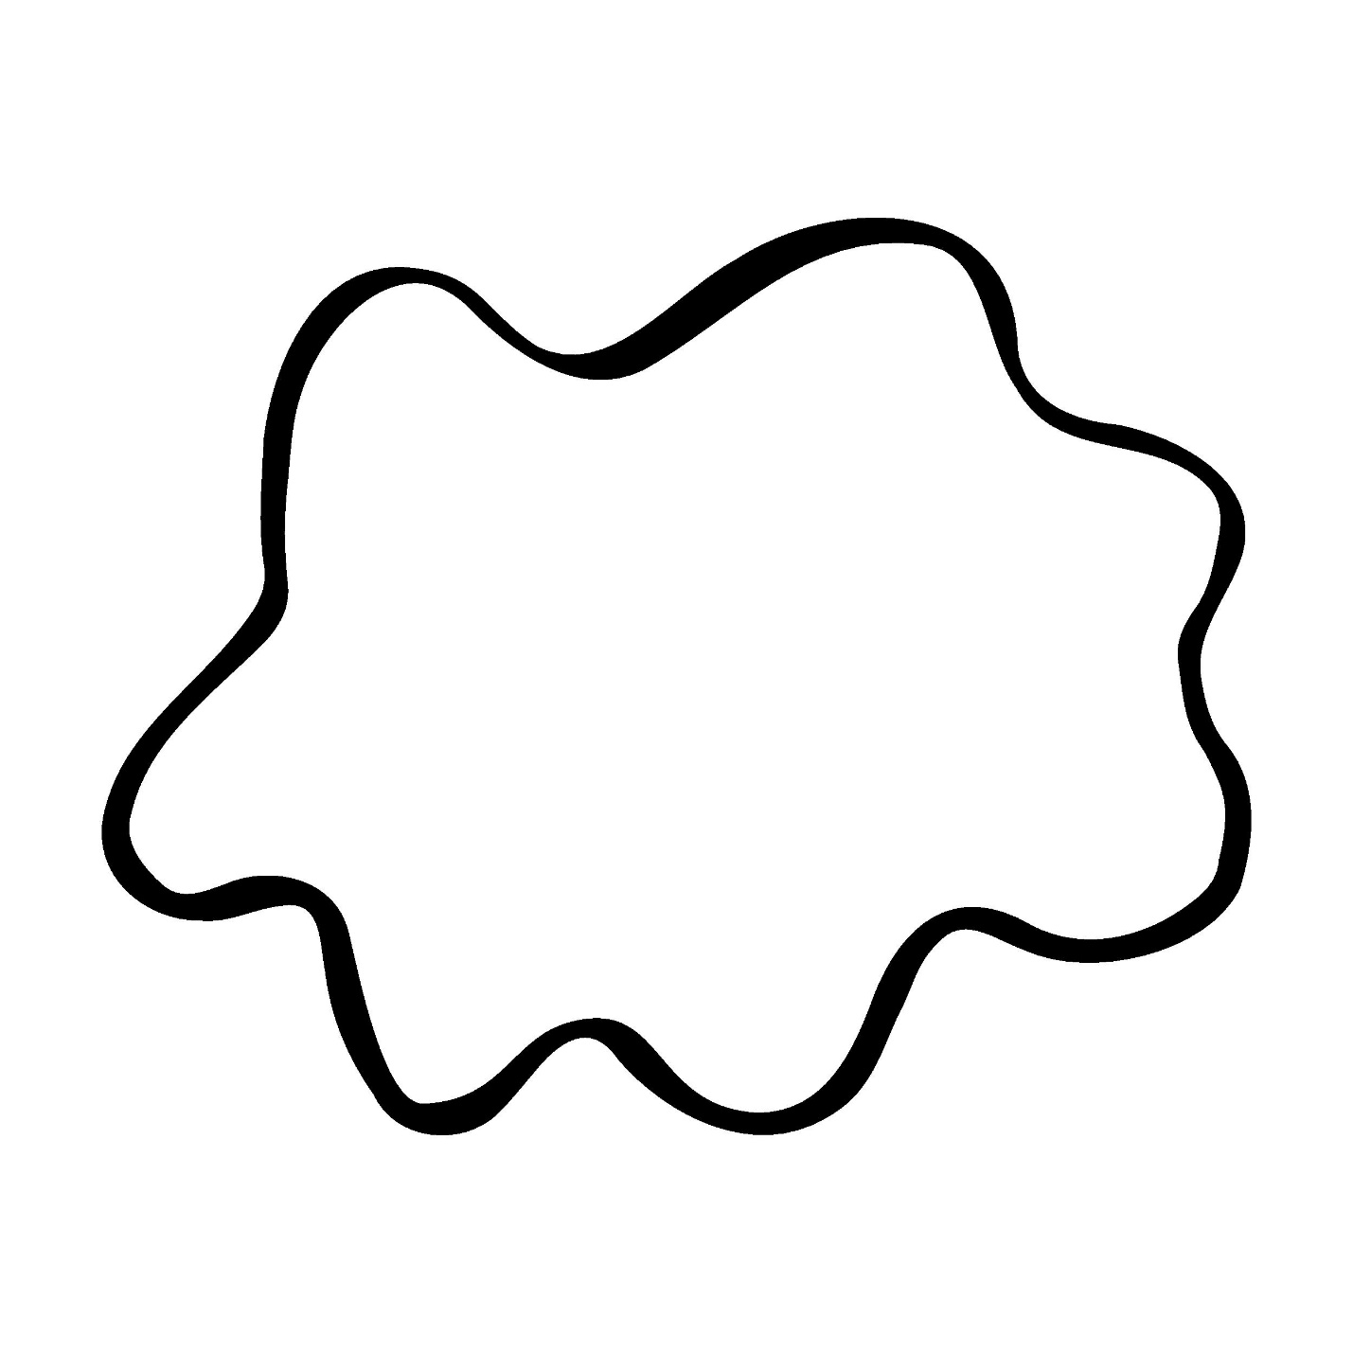
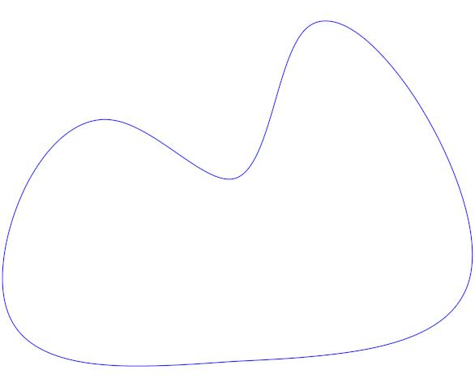
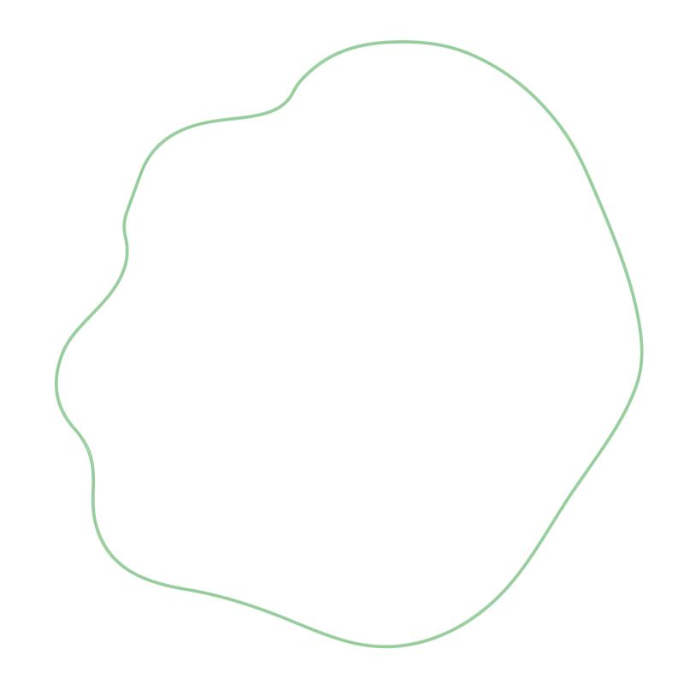
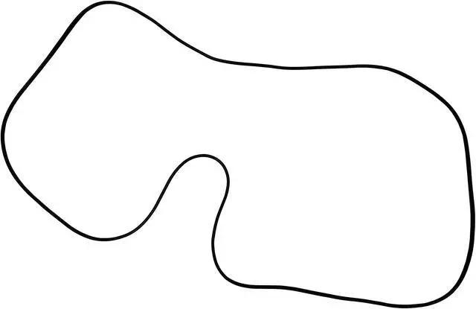

3-Symmetric Closed Wavy Shapes
# Source: AI Source: Provided by: [Data Path: Persons Table -> ID Column: 1, Name_En Column: Motasem Essam] -> From: [ChatGPT] on [7/25/2026]
A Symmetric Closed Wavy Shape has a closed wavy boundary that remains unchanged under a specified symmetry transformation.
It may have:
- Reflection symmetry.
- Rotational symmetry.
- Multiple axes of symmetry.
For reflection symmetry:
$$R\left(S\right)=S$$
where $R$is the reflection transformation and $S$is the shape.
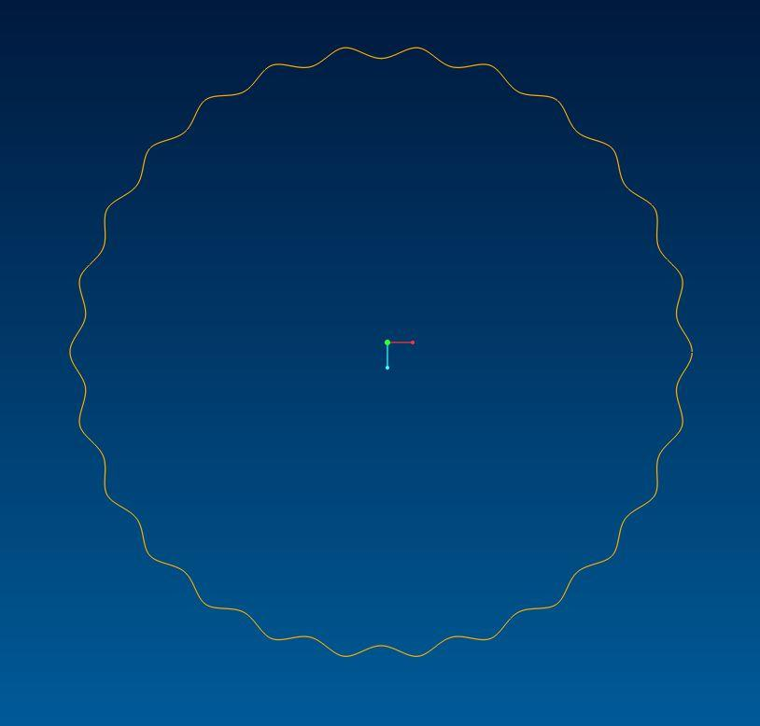

4-Asymmetric Closed Wavy Shapes
# Source: AI Source: Provided by: [Data Path: Persons Table -> ID Column: 1, Name_En Column: Motasem Essam] -> From: [ChatGPT] on [7/25/2026]
An Asymmetric Closed Wavy Shape is a closed wavy shape that does not have the particular symmetry being considered.
Its waves may have different:
- Heights.
- Widths.
- Spacing.
- Curvatures.
- Positions around the boundary.
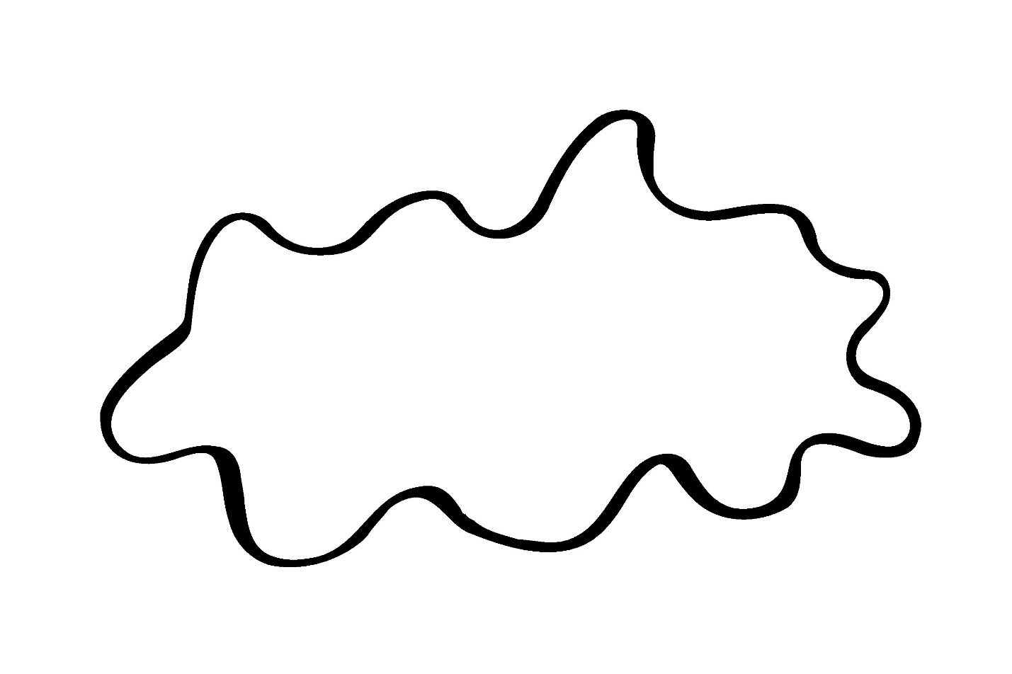
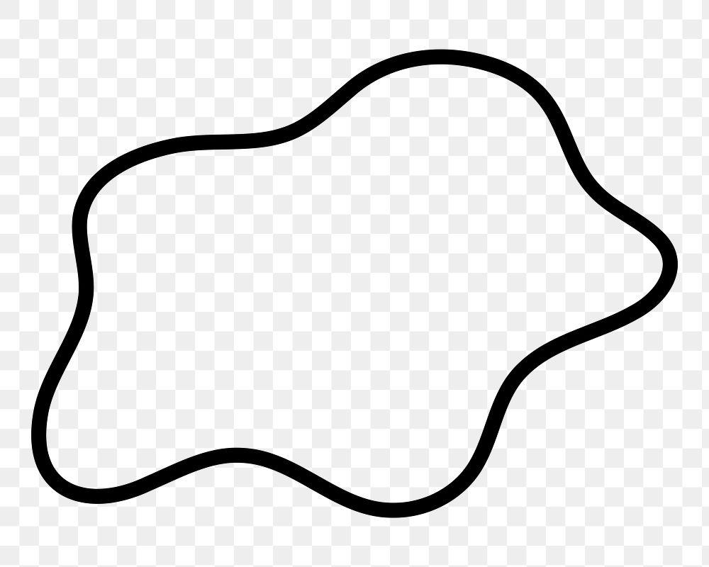
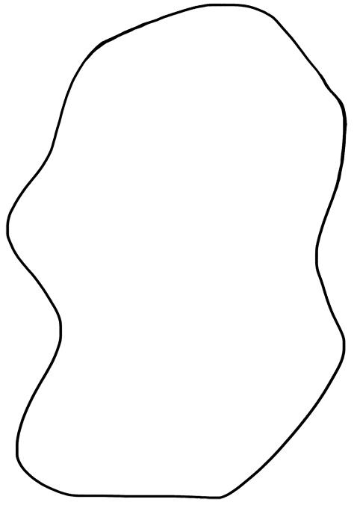

5-Periodic Closed Wavy Shapes
# Source: AI Source: Provided by: [Data Path: Persons Table -> ID Column: 1, Name_En Column: Motasem Essam] -> From: [ChatGPT] on [7/25/2026]
A Periodic Closed Wavy Shape uses a repeating wave pattern around its boundary.
For example, a radial periodic curve can be represented using
$$r\left(θ\right)=R+Asin⁡\left(nθ\right)$$
where:
- $R$= average radius.
- $A$= wave amplitude.
- $n$= number of repeating wave cycles.
- $θ$= angular parameter.
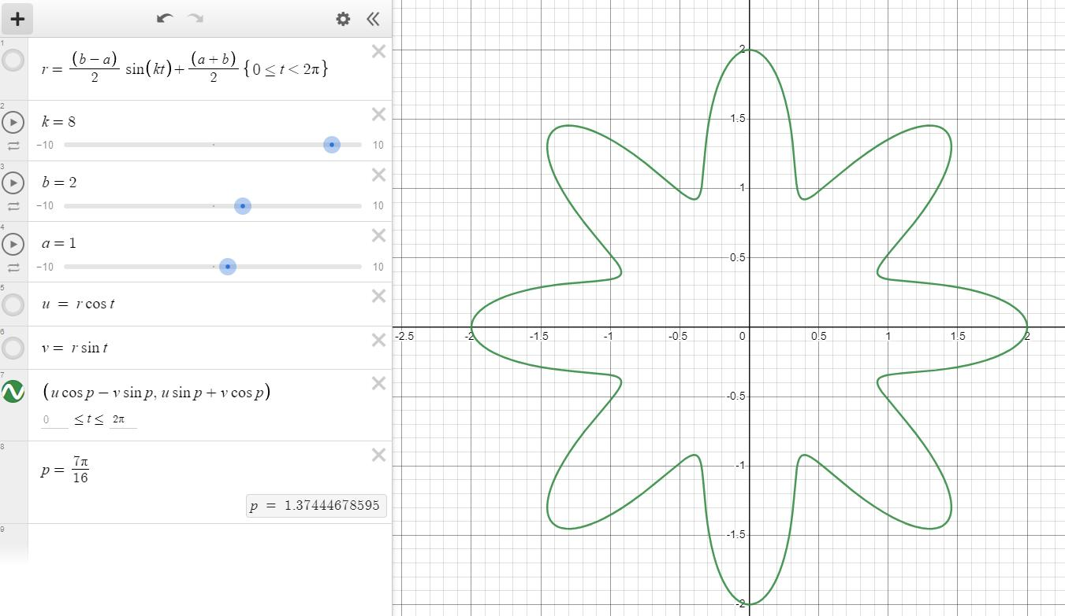
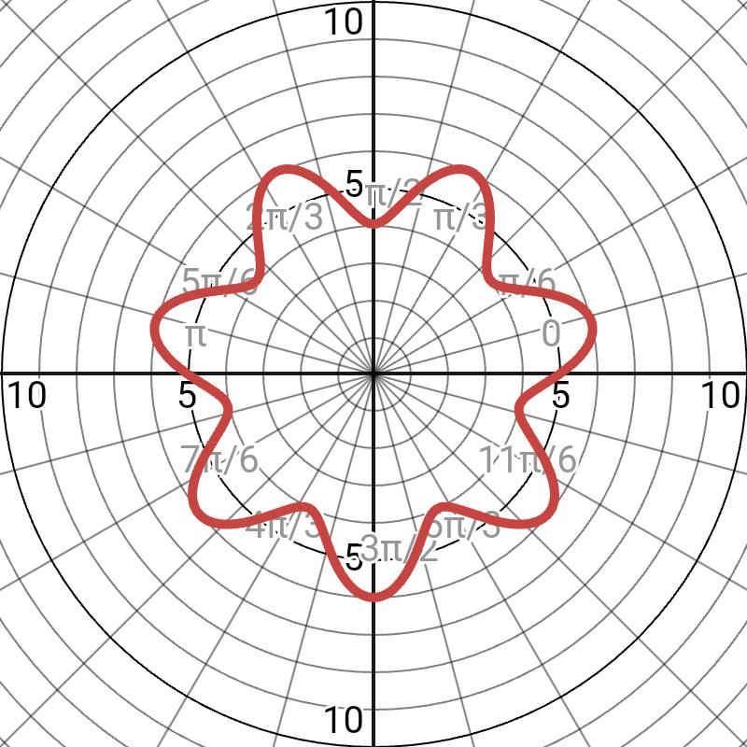
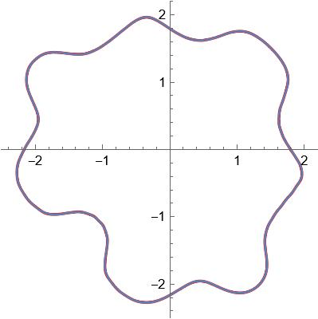
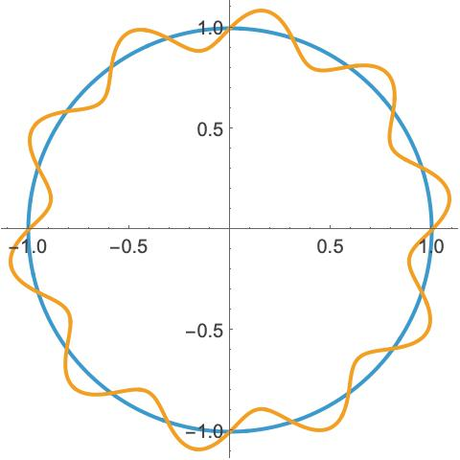

6-Freeform Closed Wavy Shapes
# Source: AI Source: Provided by: [Data Path: Persons Table -> ID Column: 1, Name_En Column: Motasem Essam] -> From: [ChatGPT] on [7/25/2026]
A Freeform Closed Wavy Shape is a closed curved form that does not follow a fixed mathematical wave pattern.
It can have:
- Unequal waves.
- Variable curvature.
- Different amplitudes.
- Non-repeating sections.
Many naturally occurring and artistic closed forms can be described this way.
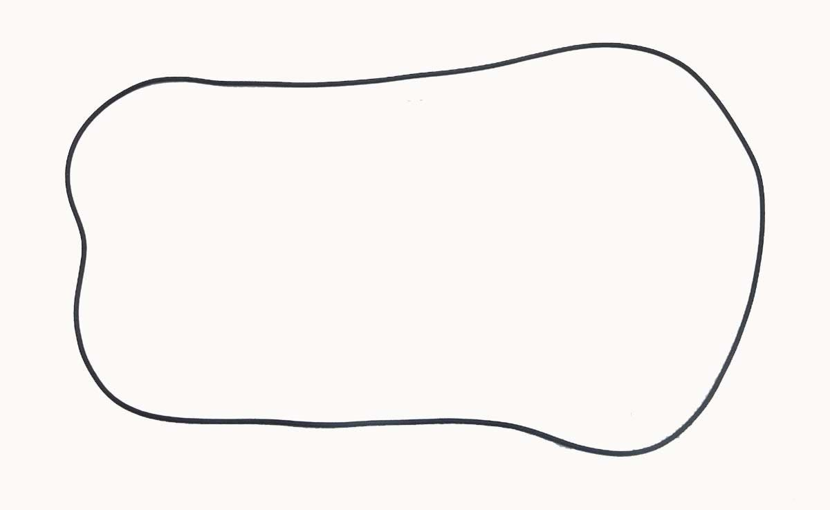
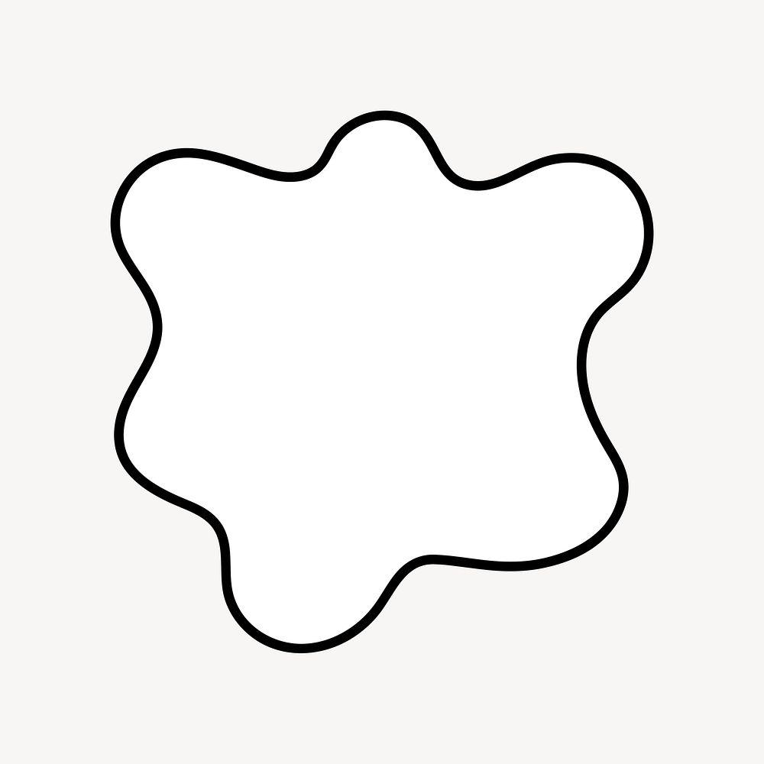
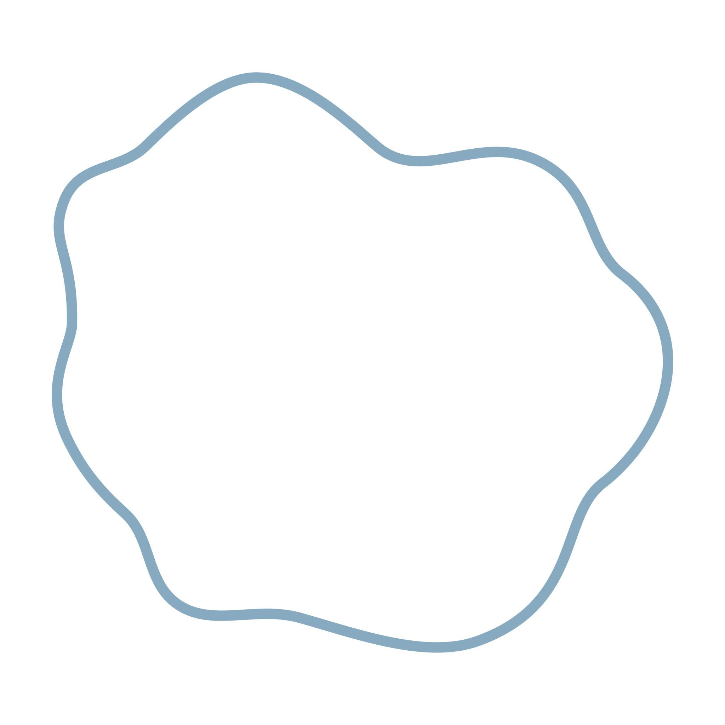
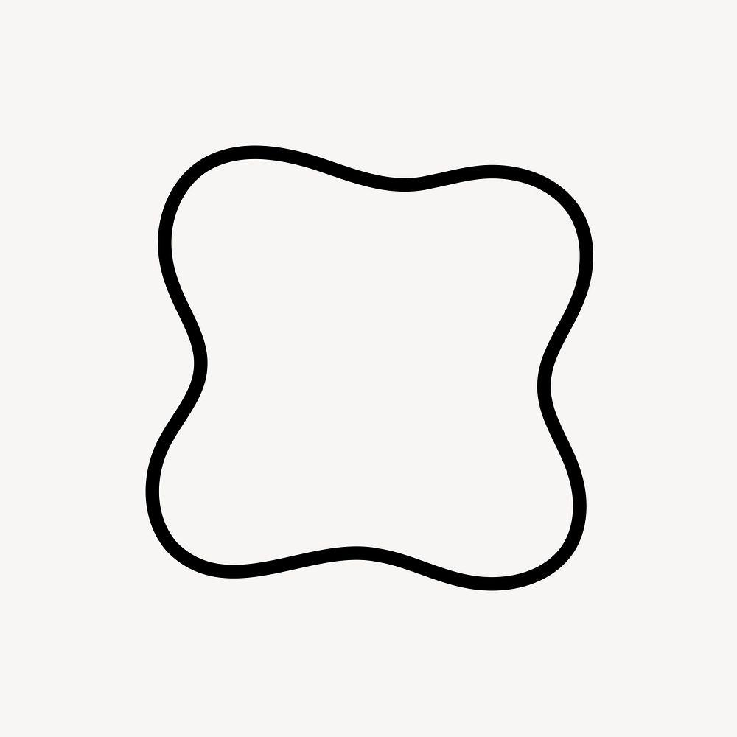
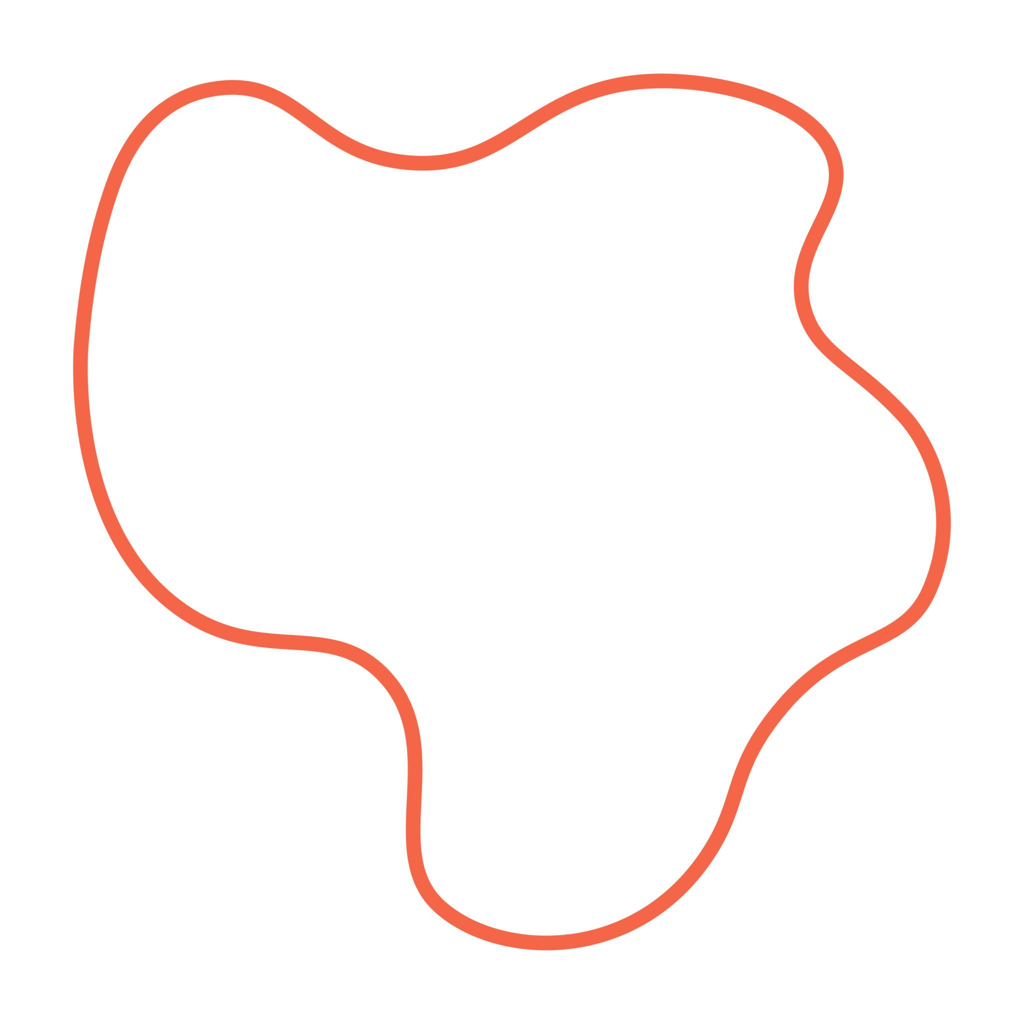

Mathematical Properties

Closure
# Source: AI Source: Provided by: [Data Path: Persons Table -> ID Column: 1, Name_En Column: Motasem Essam] -> From: [ChatGPT] on [7/25/2026]
For a parameterized curve
$$r\left(t\right)=\left(x , \left(t\right)y\left(t\right)\right)$$
the curve is closed when
$$r\left(a\right)=r\left(b\right)$$

Enclosed Area
# Source: AI Source: Provided by: [Data Path: Persons Table -> ID Column: 1, Name_En Column: Motasem Essam] -> From: [ChatGPT] on [7/25/2026]
A closed wavy shape encloses an area.
For a suitable parameterization, its signed area can be calculated using
$$A=\frac{1}{2}\oint{(}\left.x dy-y dx\right)$$
For a parameterized curve:
$$A=\frac{1}{2}\int_{a}^{b}{\left(x\left(t\right)y^{'}\left(t\right)-y\left(t\right)x^{'}\left(t\right)\right)}dt$$

Boundary Length
# Source: AI Source: Provided by: [Data Path: Persons Table -> ID Column: 1, Name_En Column: Motasem Essam] -> From: [ChatGPT] on [7/25/2026]
The length of a parameterized closed curve is
$$L=\int_{a}^{b}{\sqrt{{\left(\frac{dx}{dt}\right)}^{2}+{\left(\frac{dy}{dt}\right)}^{2}}} dt$$
This gives the total length of the wavy boundary.

Smoothness
# Source: AI Source: Provided by: [Data Path: Persons Table -> ID Column: 1, Name_En Column: Motasem Essam] -> From: [ChatGPT] on [7/25/2026]
A wavy boundary is generally characterized by a smooth change of direction.
Unlike a zigzag boundary, it normally does not contain sharp vertices such as:
$$∠ABC$$
where the direction suddenly changes.

Closed Wavy Shape vs Open Wavy Shape
# Source: AI Source: Provided by: [Data Path: Persons Table -> ID Column: 1, Name_En Column: Motasem Essam] -> From: [ChatGPT] on [7/25/2026]
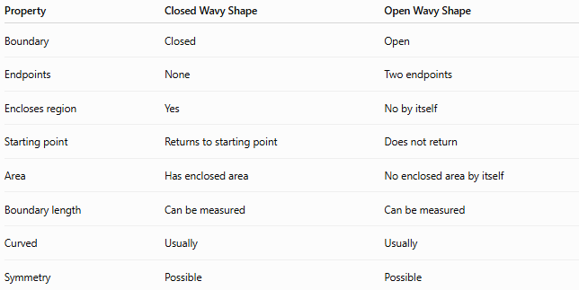
Property | Closed Wavy Shape | Open Wavy Shape
Boundary | Closed | Open
Endpoints | None | Two endpoints
Encloses region | Yes | No by itself
Starting point | Returns to starting point | Does not return
Area | Has enclosed area | No enclosed area by itself
Boundary length | Can be measured | Can be measured
Curved | Usually | Usually
Symmetry | Possible | Possible
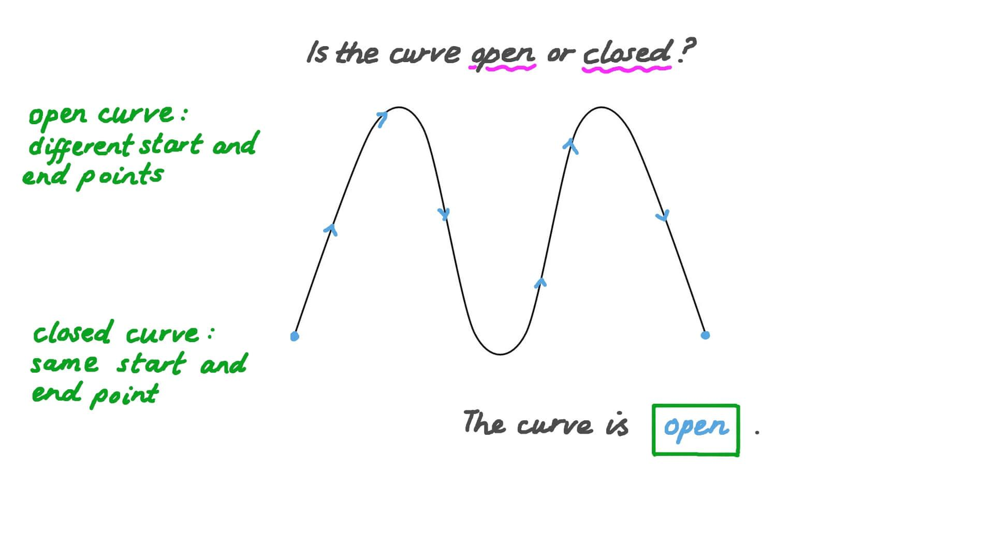
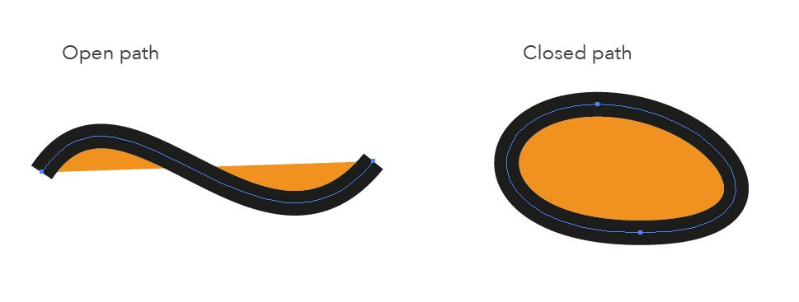
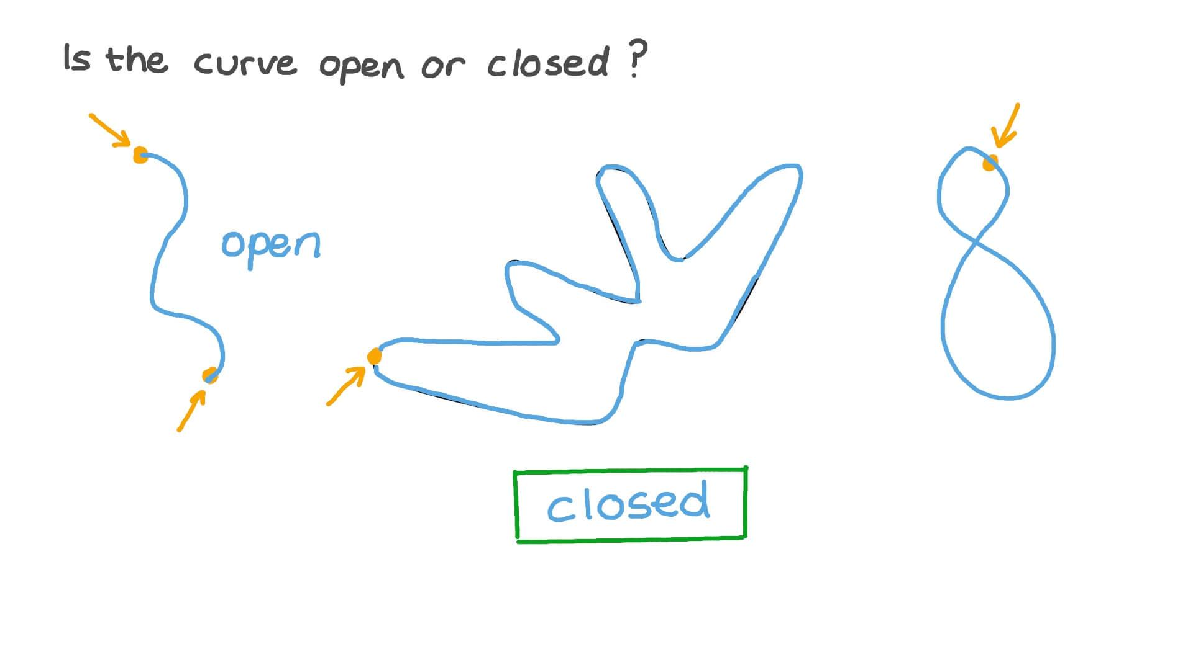
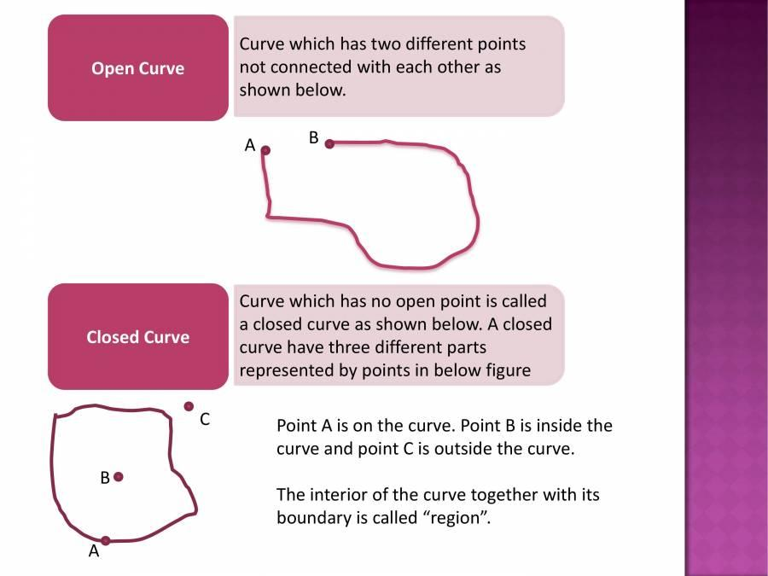

Closed Wavy Shape vs Closed Zigzag Shape
# Source: AI Source: Provided by: [Data Path: Persons Table -> ID Column: 1, Name_En Column: Motasem Essam] -> From: [ChatGPT] on [7/25/2026]
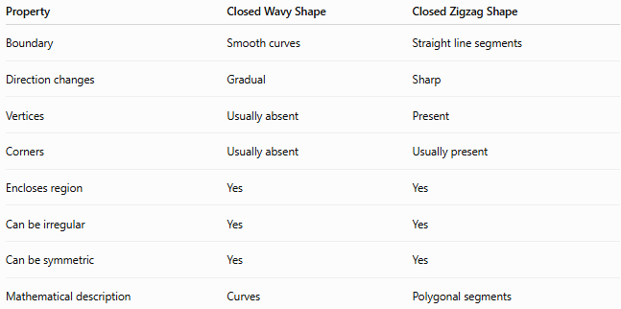
Property | Closed Wavy Shape | Closed Zigzag Shape
Boundary | Smooth curves | Straight line segments
Direction changes | Gradual | Sharp
Vertices | Usually absent | Present
Corners | Usually absent | Usually present
Encloses region | Yes | Yes
Can be irregular | Yes | Yes
Can be symmetric | Yes | Yes
Mathematical description | Curves | Polygonal segments
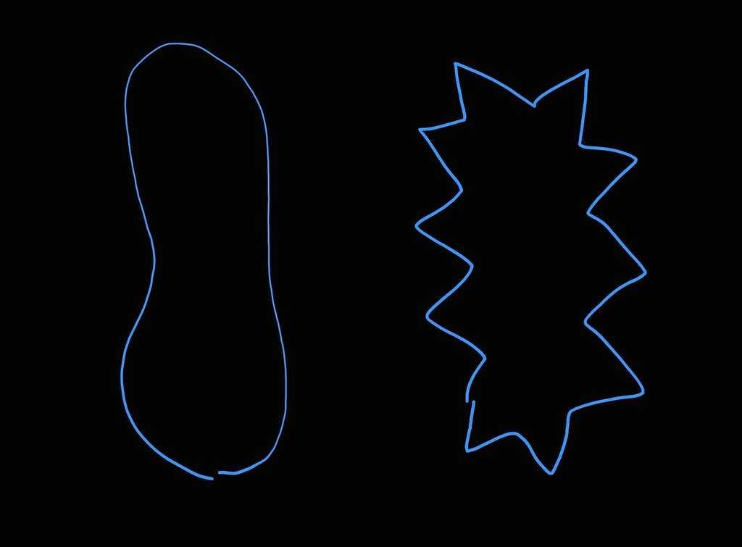
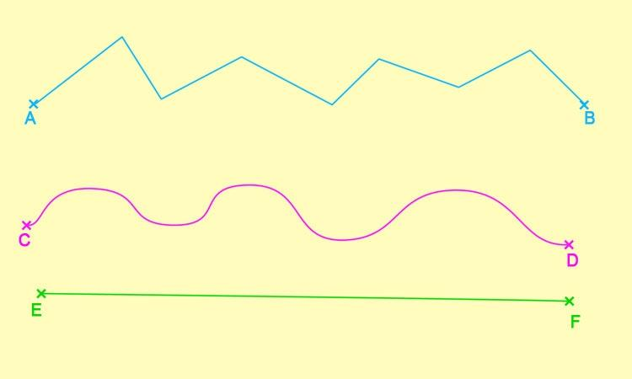
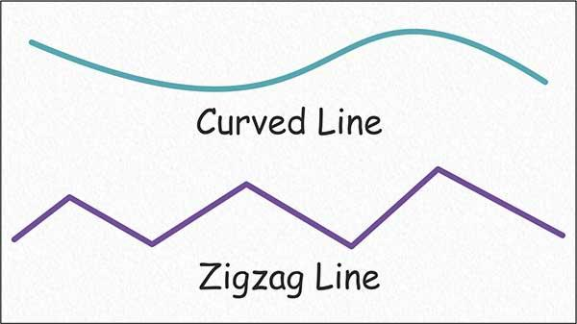

Examples
# Source: AI Source: Provided by: [Data Path: Persons Table -> ID Column: 1, Name_En Column: Motasem Essam] -> From: [ChatGPT] on [7/25/2026]
Examples of closed wavy shapes include:
- A circular boundary with repeated smooth waves.
- An irregular organic closed outline.
- A periodic radial wave.
- A flower-like smooth boundary.
- A smooth decorative closed curve.
- A symmetric repeated-wave outline.
- An asymmetric freeform closed curve.

Classification Summary
# Source: AI Source: Provided by: [Data Path: Persons Table -> ID Column: 1, Name_En Column: Motasem Essam] -> From: [ChatGPT] on [7/25/2026]
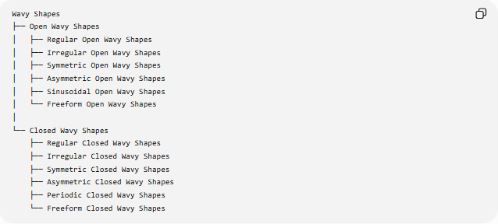
Wavy Shapes
├── Open Wavy Shapes
│ ├── Regular Open Wavy Shapes
│ ├── Irregular Open Wavy Shapes
│ ├── Symmetric Open Wavy Shapes
│ ├── Asymmetric Open Wavy Shapes
│ ├── Sinusoidal Open Wavy Shapes
│ └── Freeform Open Wavy Shapes
│
└── Closed Wavy Shapes
├── Regular Closed Wavy Shapes
├── Irregular Closed Wavy Shapes
├── Symmetric Closed Wavy Shapes
├── Asymmetric Closed Wavy Shapes
├── Periodic Closed Wavy Shapes
└── Freeform Closed Wavy Shapes

Key Points
# Source: AI Source: Provided by: [Data Path: Persons Table -> ID Column: 1, Name_En Column: Motasem Essam] -> From: [ChatGPT] on [7/25/2026]
- A Closed Wavy Shape has a continuous closed boundary.
- It has no endpoints.
- Its boundary returns to its starting point.
- It encloses a region of the plane.
- Its boundary is generally smooth and curved.
- Closed wavy shapes may be regular, irregular, symmetric, asymmetric, periodic, or freeform.
- The enclosed area can be calculated using line-integral methods for suitable parameterizations.
- A closed wavy shape differs from a closed zigzag shape mainly through its smooth curved boundary versus straight segments and sharp turns.

Conclusion
# Source: AI Source: Provided by: [Data Path: Persons Table -> ID Column: 1, Name_En Column: Motasem Essam] -> From: [ChatGPT] on [7/25/2026]
A Closed Wavy Shape is a closed geometric or descriptive form whose boundary follows a smooth, wave-like path and encloses an area. It provides a useful category for describing shapes that are neither standard polygons nor simple circular or elliptical forms, while still having a continuous closed boundary.

